调研问卷链接方式
序号 | 调研对象 | 微信二维码 | 网页链接
1 | 专业学位应届毕业生(含在职毕业生) | 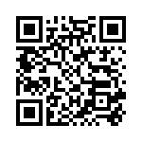 | https://xiaowaidaoshi.sojump.com/jq/14703153.aspx
2 | 学术学位应届  毕业生 | 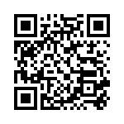 | https://xiaowaidaoshi.sojump.com/jq/14702837.aspx
3 | 校友 | 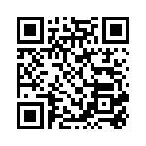 | https://xiaowaidaoshi.sojump.com/jq/14703046.aspx
4 | 专业学位点负责人 | 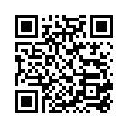 | https://xiaowaidaoshi.sojump.com/jq/14701637.aspx
5 | 合作培养单位 | 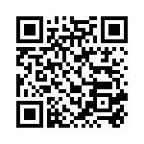 | https://xiaowaidaoshi.sojump.com/jq/14702541.aspx
6 | 校内导师 | 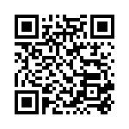 | https://xiaowaidaoshi.sojump.com/jq/14702464.aspx
7 | 校外导师 | 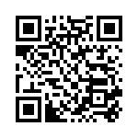 | https://xiaowaidaoshi.sojump.com/jq/14701898.aspx
8 | 高校管理人员 | 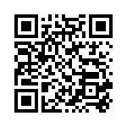 | https://xiaowaidaoshi.sojump.com/jq/14703478.aspx
9 | 用人单位 | 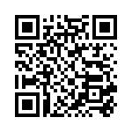 | https://xiaowaidaoshi.sojump.com/jq/14701299.aspx

